**SEP Signature Page Information Before Starting the 526 Claim**

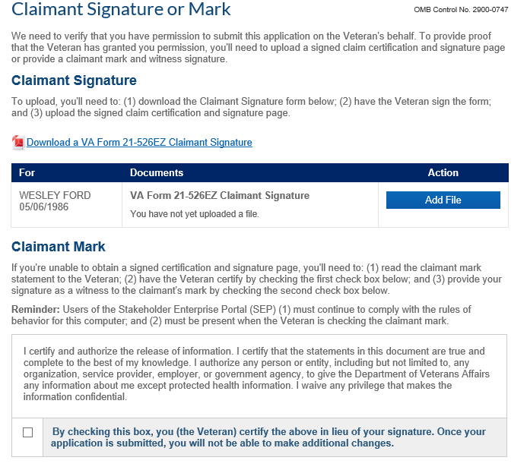

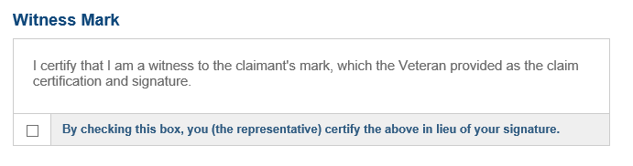

This box appears if the claimant mark box is checked above.

**Link to manual guidance on Check Box Solution for Claims Submitted by VSOs**

<https://vaww.vrm.km.va.gov/system/templates/selfservice/va_kanew/help/agent/locale/en-US/portal/554400000001034/content/554400000031400/M21-1-Part-III-Subpart-i-Chapter-4-Section-B-The-Stakeholder-Enterprise-Portal-SEP-Role-in-the-Veterans-Online-Application-VONAPP-Direct-Connect-VDC-Process?query=checkmark>